DSCI 558: Building Knowledge Graphs

Quiz 13 (5 minutes)

Question 1 (8 points):
Match the following tables with their correct types: Horizontal Listings, Vertical Listings, Attribute/Value Tables, Matrix
Label each black with the following values: subject, predicate, object

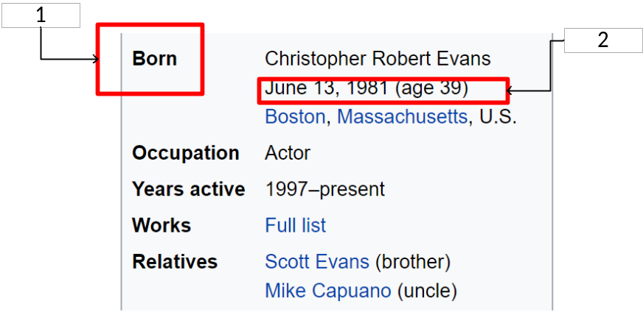
Type: attribute/value
Box 1: Predicate
Box 2: Object
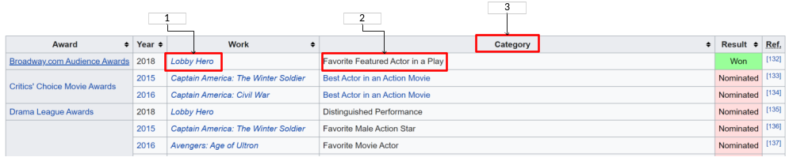
Type: Horizontal Listings
Box 1: Subject/object with consider “main” column is work/award
Box2: Object
Box3: Predicate
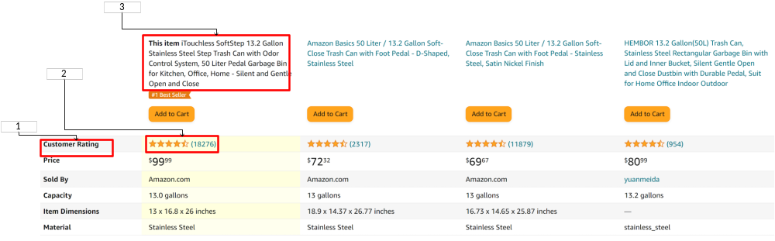
Table Type: Vertical Listings
Box 1: Predicate
Box 2: Object
Box 3: Subject
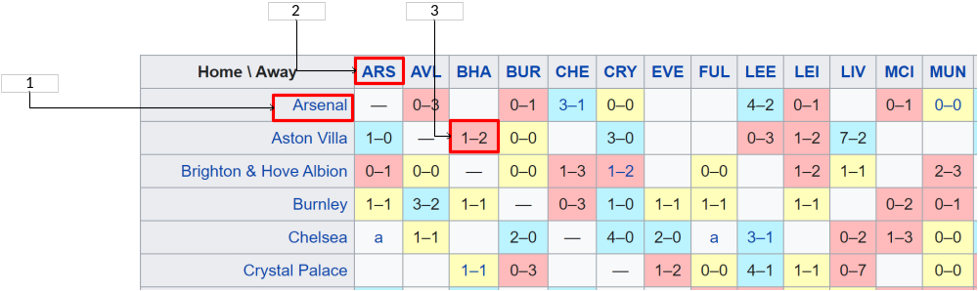
Table Type: Matrix
Box 1: Subject
Box 2: Subject
Box 3: Object
Question 2 (2 points):
Arrange the following table understanding steps in the correct order.
Correct order:
- Assigning types to cells based on the types of the adjacent cells
- Clustering cells with the same functional roles into the same groups
- Predicting relationships between different blocks in the tables

